***NAME : Himanshu Dixit***

***ENROLL NO. : B64178***

***BATCH : B10***

***SOFTWARE DEVELOPMENT FUNDAMENTAL LAB-I(15B17CI171) Assignment Sheet (WEEK-8 PHASE-2)***

***Lab A***

1. a) Write a structure to store the names, salary and employee id of 10 employees in a company.

**Solution:**

#include<stdio.h>

struct employee

{

char name[20];

int salary;

char empid[10];

}emp[10];

int main()

{

//struct employee emp[10];

printf("Enter the details of 10 employees\n");

for(int i=0;i<10;i++)

{

printf("enter %d employee details\n",i+1);

scanf("%s",emp[i].name);

scanf("%d",&emp[i].salary);

scanf("%s",emp[i].empid);

}

for(int i=0;i<10;i++)

{

printf("%d employee details :",i+1);

printf("%s ",emp[i].name);

printf("%d ",emp[i].salary);

printf("%s\n",emp[i].empid);

}

return 0;

}

b) Write a program to increase the salary depending on the number of hours of work per day as follows and then print the name of all the employees along with their final salaries.

|  |  |  |  |
| --- | --- | --- | --- |
| **Hours of work per day** | 8 | 10 | >=12 |
| **Increase in salary** | 50 | 100 | 150 |
|  |  |  |  |

**Solution:**

#include<stdio.h>

struct employee

{

char name[20];

int salary;

int hrs;

}emp[10];

int main()

{

//struct employee emp[10];

printf("Enter the details of 10 employees\n");

for(int i=0;i<10;i++)

{

printf("enter %d employee details\n",i+1);

scanf("%s",emp[i].name);

scanf("%d",&emp[i].salary);

scanf("%d",&emp[i].hrs);

}

for(int i=0;i<10;i++)

{

printf("%d employee details :",i+1);

printf("%s ",emp[i].name);

if(emp[i].hrs>=8&&emp[i].hrs<10)

emp[i].salary=emp[i].salary+50;

if(emp[i].hrs>=10&&emp[i].hrs<12)

emp[i].salary=emp[i].salary+100;

if(emp[i].hrs>=12)

emp[i].salary=emp[i].salary+150;

printf("%d/-\n",emp[i].salary);

}

return 0;

}

1. Write a program to add two distances in the inch-feet system using structures.

**Solution:**

#include<stdio.h>

struct distance

{

int inches;

int feet;

}d1,d2;

int main()

{

int sumi,sumf;

printf("enter distance 1 in feet and inche ");

scanf("%d %d",&d1.feet,&d1.inches);

printf("enter distance 2 in feet and inche ");

scanf("%d %d",&d2.feet,&d2.inches);

sumf=d1.feet+d2.feet;

sumi=d1.inches+d2.inches;

if(sumi>=12)

{

int a=sumi/12;

sumi=sumi%12;

sumf=sumf+a;

}

printf("sum is %d feet and %d inches",sumf,sumi);

return 0;

}

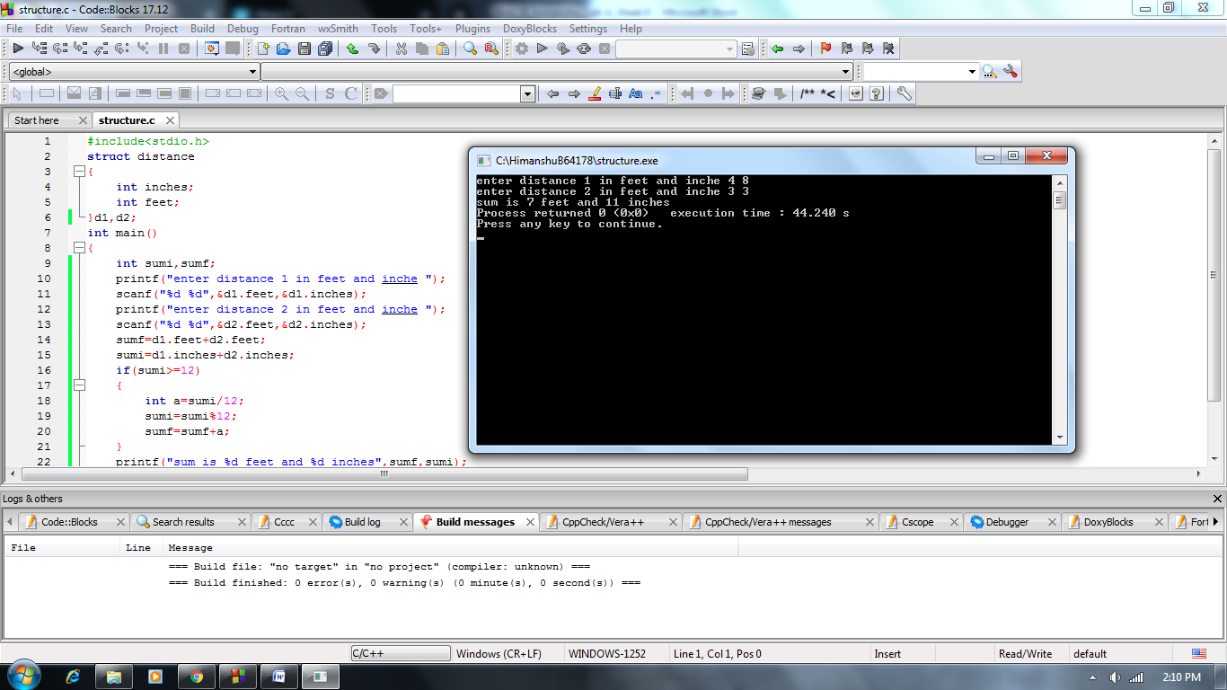

1. Write a program to print the tickets of the boarders of a boat using array of structures with initialization in the program. Create boat structure with name, seat_number and fare.

**Solution:**

#include<stdio.h>

struct boat

{

char name[20];

int seat_no;

float fair;

};

int main()

{

struct boat b[2]={{"himanshu",1,10.00},{"harsh",2,15.00}};

printf("Boarder tkt number fair : ");

for(int i=0;i<2;i++)

{

printf("\n%s %f",b[i].name,b[i].fair);

}

return 0;

}

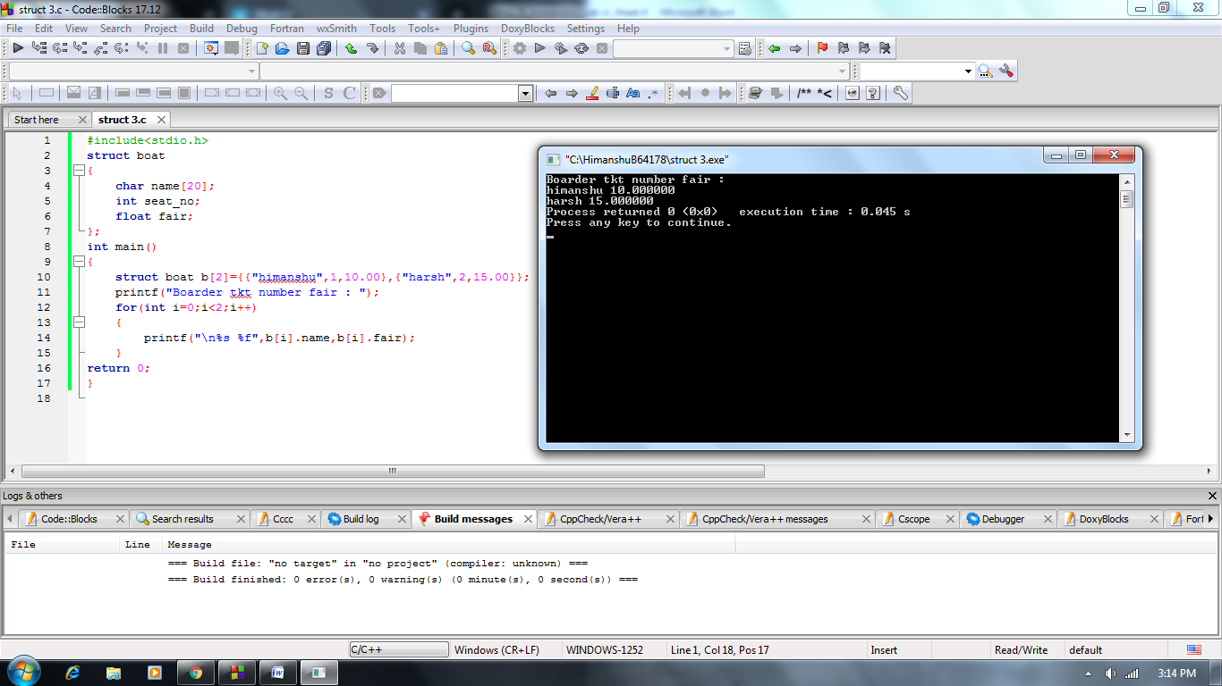

1. Write a program using a function that does not require any parameter to be passed and returns a structure.
2. Create structure A with char, integer and float variable.
3. Create function read to return struct type. // struct A read();
4. Create show function to display the values of structure type.

// void show(struct A);

**Solution:**

#include<stdio.h>

struct str

{

char ch;

int i;

float f;

};

struct str read()

{

struct str a;

scanf("%c %d %f",&a.ch,&a.i,&a.f);

return a;

}

void show(struct str b)

{

printf("\n%c %d %f",b.ch,b.i,b.f);

}

int main()

{

struct str s;

s=read();

show(s);

return 0;

}

